**Tires:**

We could run airless

* Honeycomb insert
* They’re 3d Printable
  + <https://felfil.com/3d-printing-airless-bicycle-tire-with-tpu-bigrap-project-felfil/?v=058f38ac9331>
* Michelin AIrless tire (they exist), the Uptis
  + 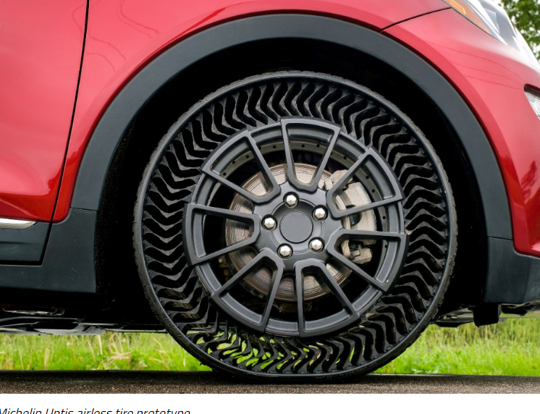
  + <https://www.greencarreports.com/news/1142940_airless-tires-look-like-the-future-for-robotaxis-evs>
  + Can’t go flat
  + Much longer longevity
  + Can hold higher curb weights

Mars Rover Wheels

* Originally used rigid wire meshes and cleats
  + 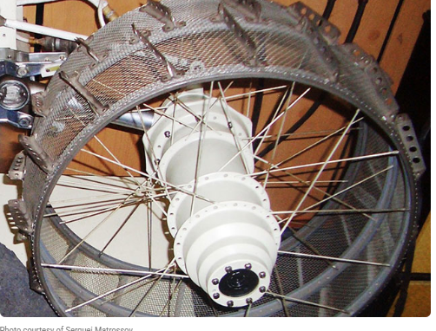
  + Great for rough terrain, not great for comfort
* Spring Airless Tires
* 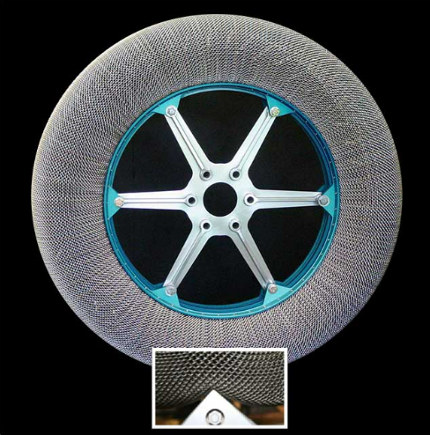
* <https://www3.nasa.gov/specials/wheels/>

**Wheelbases**

* Trike
  + Not as stable
  + Really good maneuverability
  + Easy to make
  + Lighter, easier to carry
* Quad
  + Generic
  + Heavy, stable
  + Not very nimble
* Single massive rolling ball as a wheel
  + Stupid
  + Funny tho
  + At least its innovative
* Opposite trike
  + One in the back, two in the front
  + Like the Polaris Slingshot
  + Better handling and control
  + Less stability